How to set up the initial pet food store PHP project

1. Download the pet-food-store project from the repo

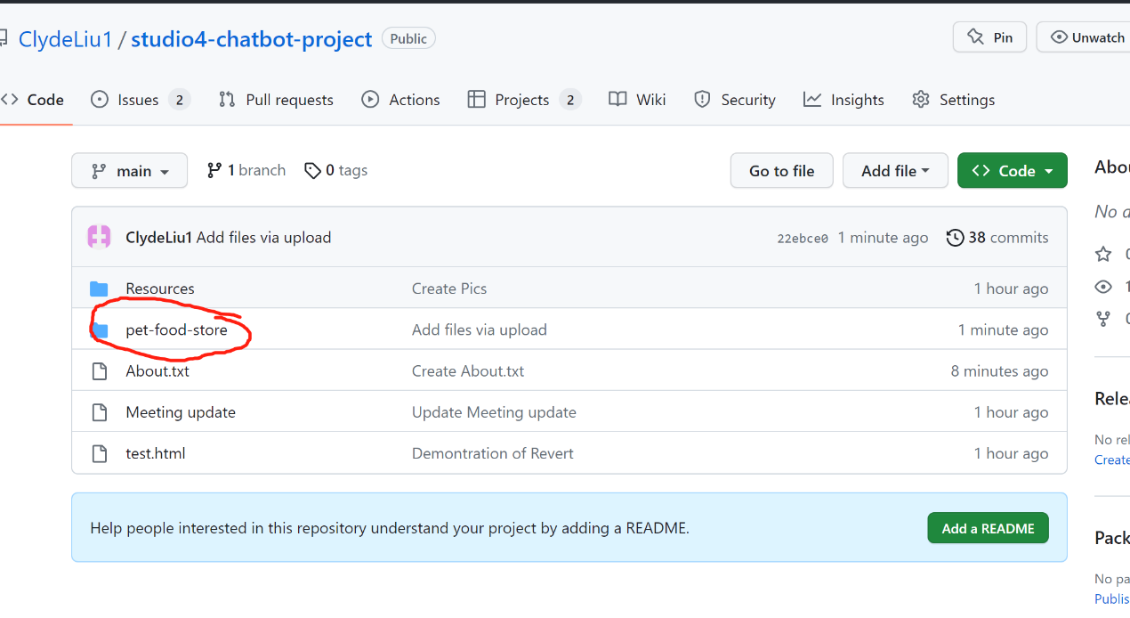

1. Open Laragon Clicking Start All then Open the Root file

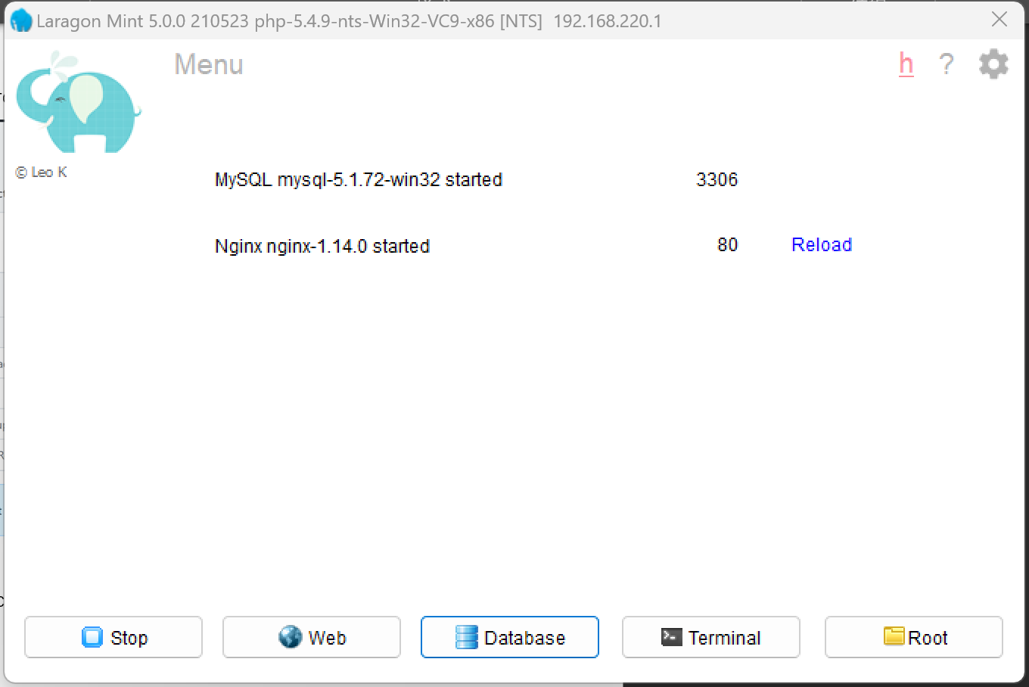

1. Cut or copy the pet-store-project file that you downloaded from GitHub, Paste in the Root file (Do not paste sql file)

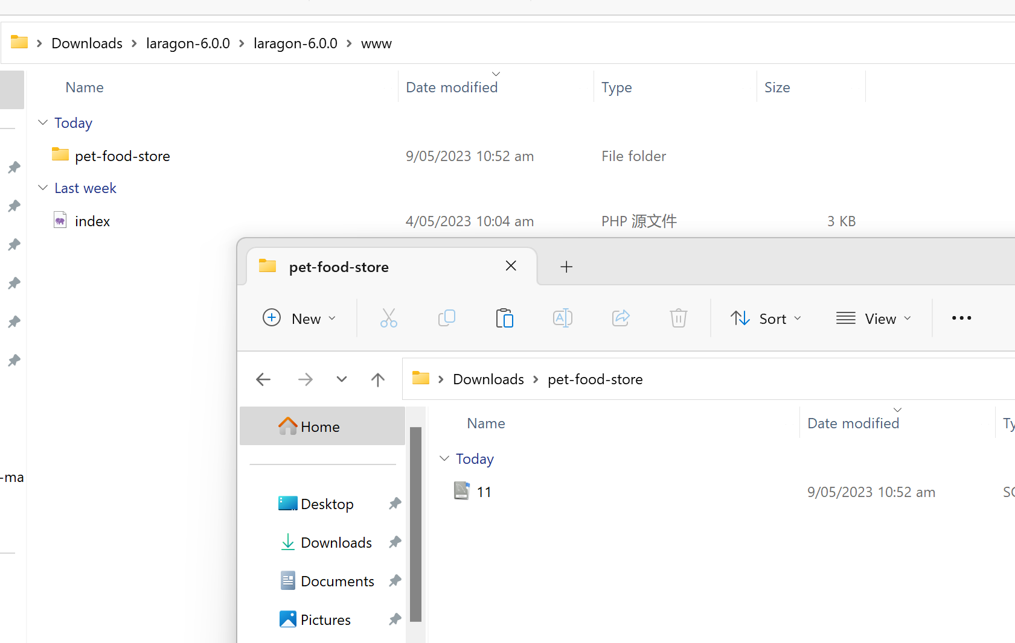

1. Open 11.SQL file Copy all the code, then Open the Laragon and click the database button.

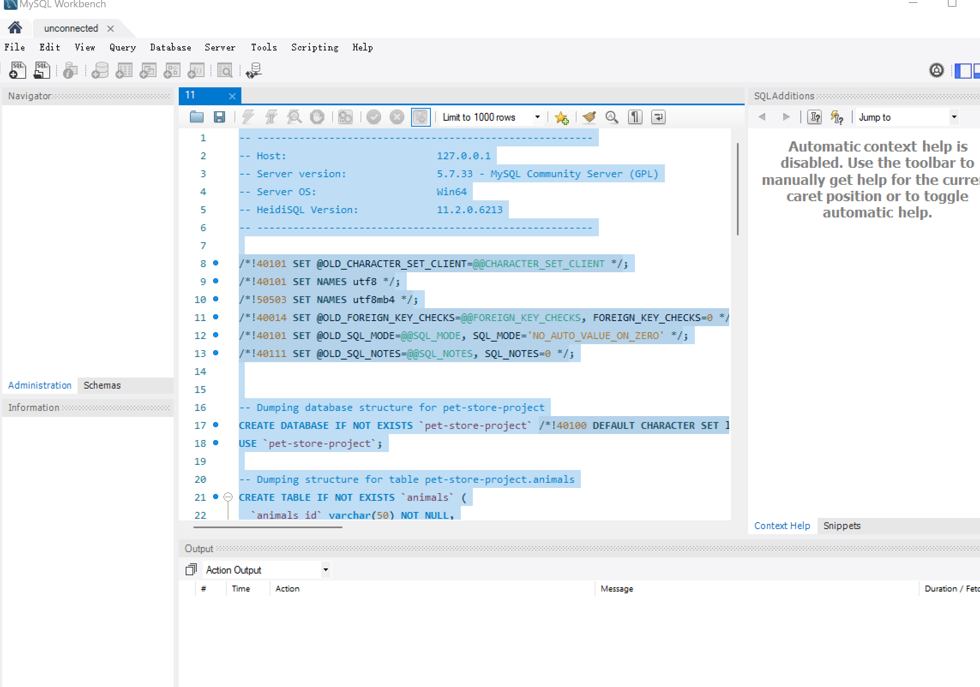

1. Create a new database and click open(Make sure the port number is the same as your laragon port number 3306)

\*\*\*Suggested to set a strong password to make sure the database is secure.

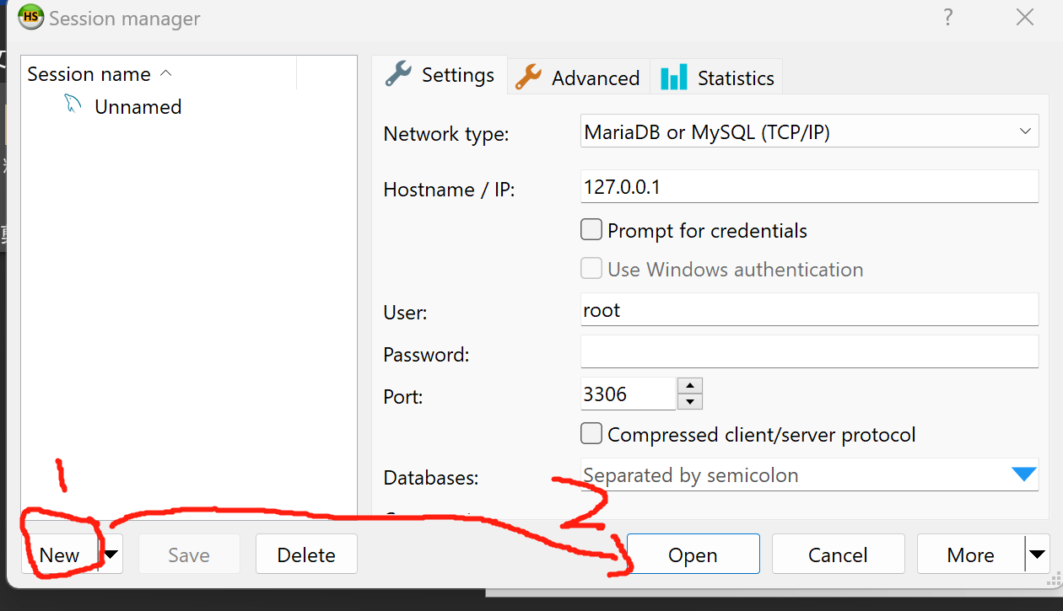



1. Paste the code that you copied to Query then click run the Query

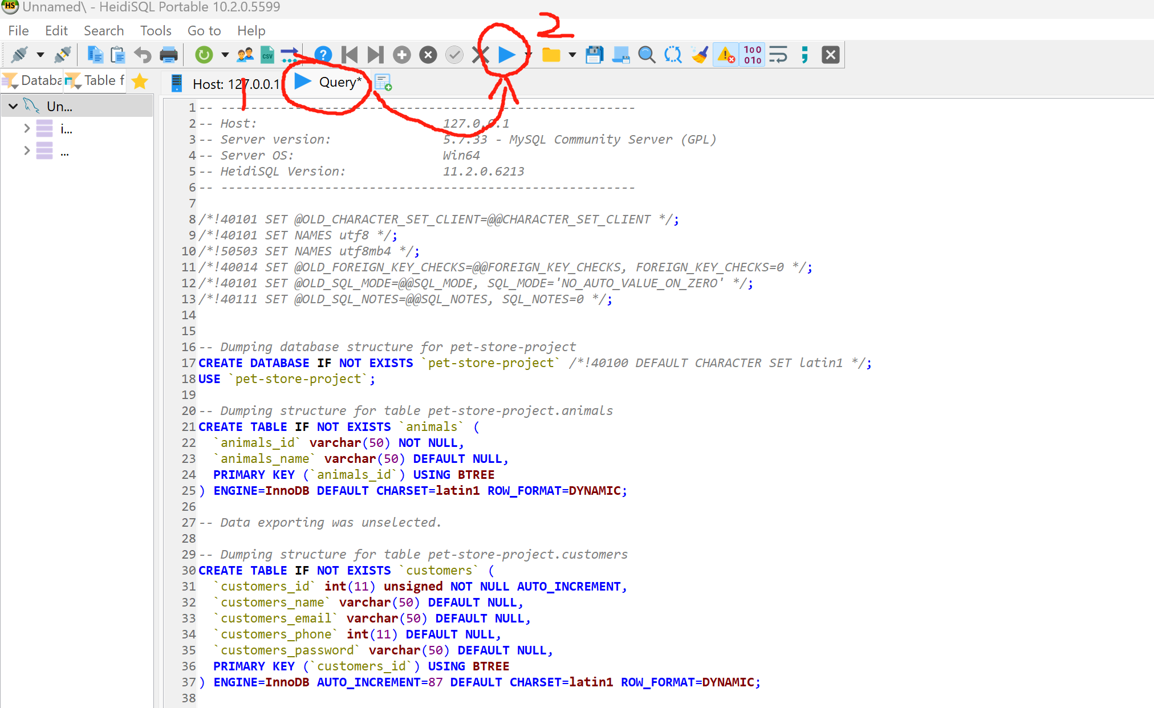

1. Right click the left menu choose refresh, then the project file will display on the menu

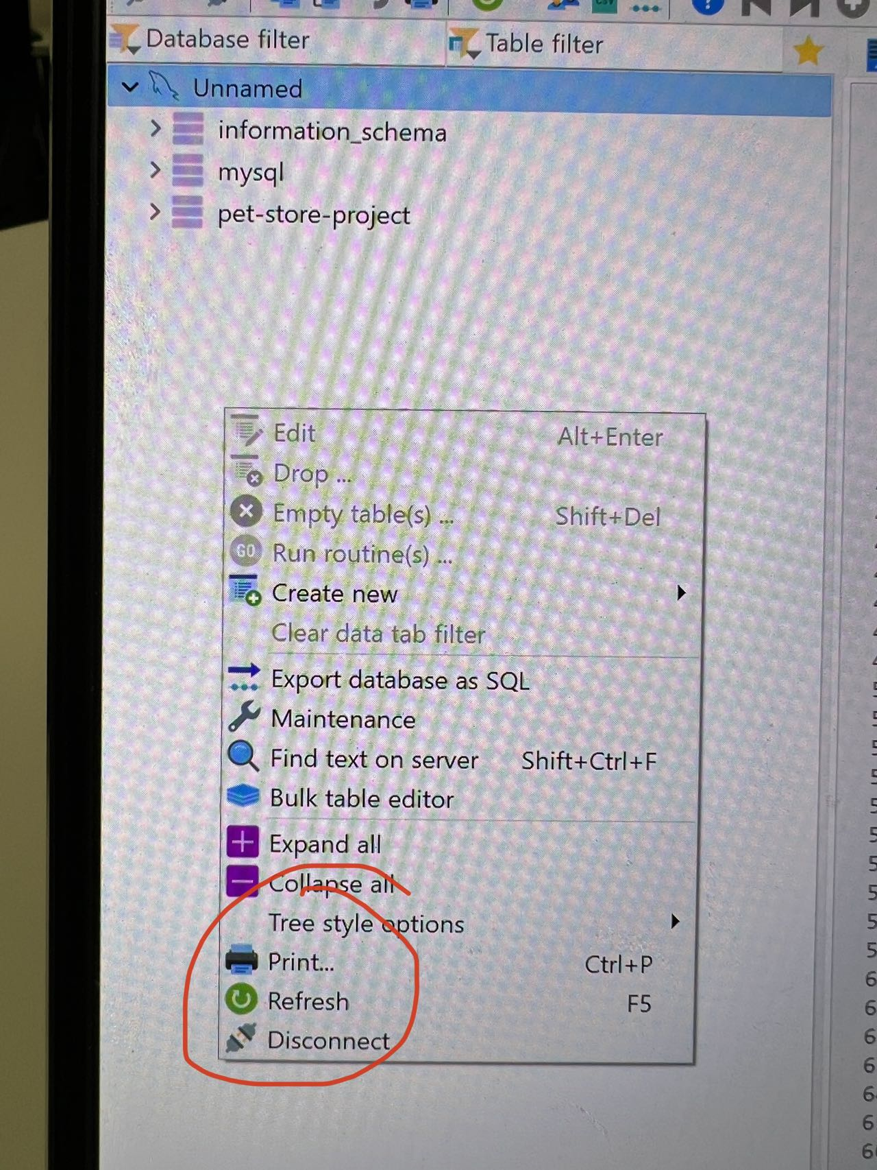

1. Open the browser tap: localhost/pet-food-store (make sure your laragon is started)

If it’s not working then tap localhost:/(plus your laragon apache port number(usually 80 or 81))/pet-food-store Make sure the following path is the same as laragon www folder

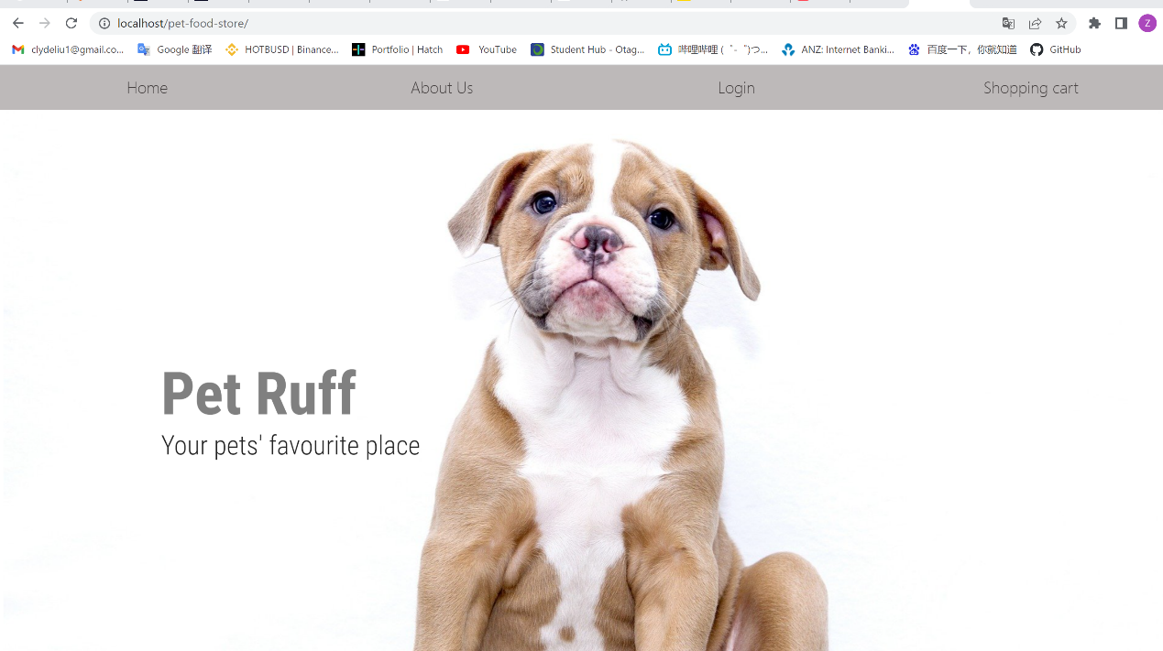



Nice All done! You should see the project now